Python CALENDAR Tutorial with Example

Calendars are very easy to use in Python. Calendars are used in many applications like inventory management systems in which you have to go back and forth between different dates.

Let’s take a look at an example of how to print the January month Calendar in Python.

|  |
| --- |
| import calendar calen = calendar.TextCalendar(calendar.SUNDAY) str = calen.formatmonth(2020,1) print(str) |

The output will be.

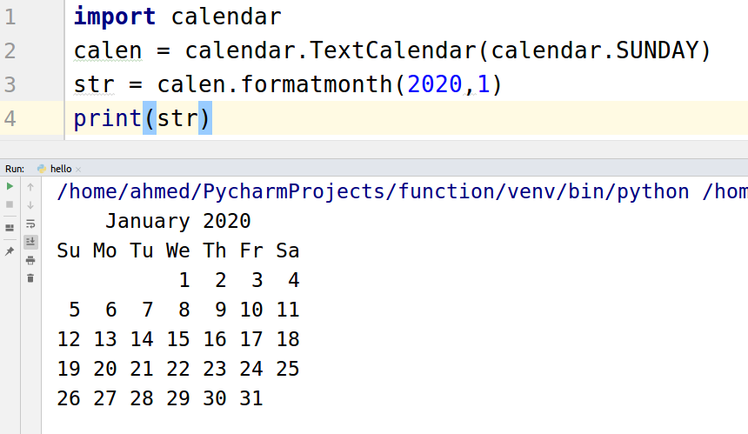

calen = calendar.TextCalendar(calendar.SUNDAY)

The calendar.SUNDAY will set the format of the calendar. As you can see above that the calendar starts with Sunday.

str = calen.formatmonth(2020,1)

Here “2020” is the year and “1” is the month

# Printing Calendar in HTML

Developers usually need a calendar in HTML format to make changes in the look and feel. So let’s see how to print the calendar in HTML format.

|  |
| --- |
| import calendar calen = calendar.HTMLCalendar(calendar.SUNDAY) str = calen.formatmonth(2020,1) print(str) |

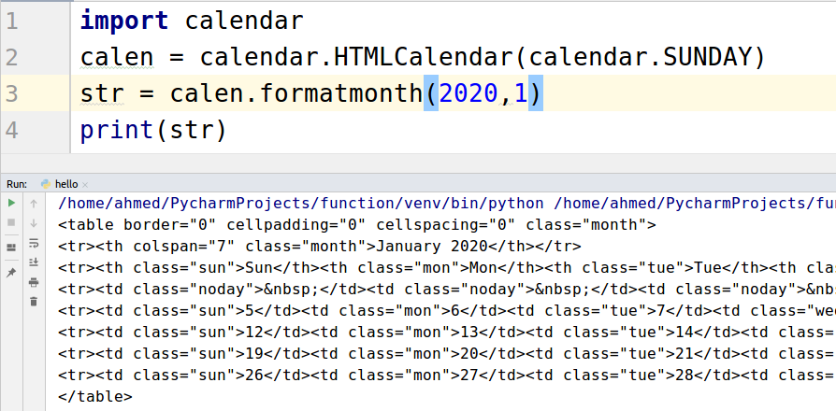

calen = calendar.HTMLCalendar(calendar.SUNDAY)

The only thing that changed in the code is the above line in which we first used TextCalendar and now using HTMLCalender.

# Loop over the Month

Sometimes we need to loop over the month days. For that purpose Let’s take a look at the how-to loop over the month of January 2020.

|  |
| --- |
| import calendar calen = calendar.TextCalendar(calendar.SUNDAY) for i in calen.itermonthdays(2020,1):  print(i) |

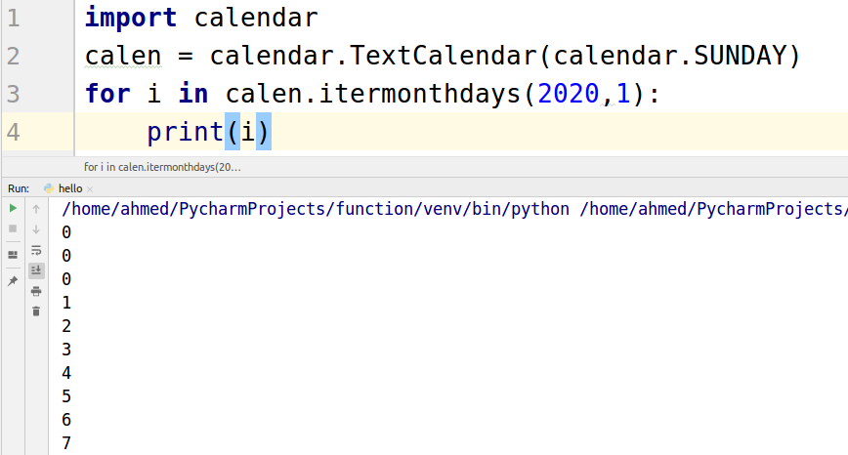

Using loop we can also print the month name.

|  |
| --- |
| import calendar for i in calendar.month_name:  print(i) |

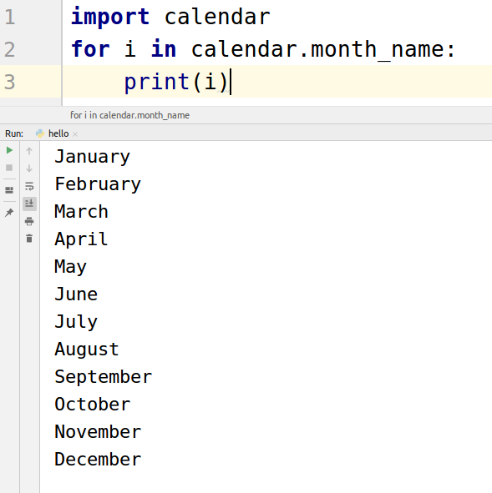

Let’s print the day names using a loop.

|  |
| --- |
| import calendar for i in calendar.day_name:  print(i) |

